
Marking key Task Three: Respiratory System (39 marks)

1 | B
2 | A
3 | A
4 | A
5 | A

6. Define the following
Description | Mark
Aerobic respiration- form of respiration that uses oxygen. | 1
Anaerobic respiration- form of respiration without oxygen that involves the incomplete breakdown of glucose | 1
 | /2

7. How is an oxygen debt created and how is it repaid?
Description | Mark
As less energy is released during anaerobic respiration than aerobic, it produces an oxygen debt. E.g. the amount of oxygen needed to oxidise lactic acid to carbon dioxide and water is less than required. | 2
 | /2

8. Identify and describe the three rules of the cell theory?
Description | Mark
Rule One: All organisms are made up of one or more cells. E.g. unicellular or multicellular. | 1
Rule Two: All the life functions of an organism occur within cells E.g. cellular respiration, energy production, instruction from nucleus. | 1
Rule Three: All cells come from pre-existing cells E.g. mitosis and meiosis. | 1
 | /3

9. Describe the function of the cell membrane
Description | Mark
Control what goes in and out of the cell | 1
It is semi-permeable as some molecules can go through the cell membrane but some cannot | 2
 | /3

10. Identify and describe the four features for efficient gas exchange. You may include a diagram to aid your response
Description | Mark
Thin: the alveoli walls are very thin so that gases can quickly diffuse through them | 1
Moist: the alveoli are moist with mucus so that gases can dissolve because of diffusing | 1
Large Surface Area: the surface area for gases to diffuse through in human lungs is roughly the same area is roughly the same as a tennis court | 2
Good blood supply: the alveoli have a large capillary network so that large volumes of gases can be exchanged. | 2
Note: If diagram is included it must be neat, in pencil, 2d and labelled.
 | /6

11. With the aid of a diagram, explain how the diaphragm assists in breathing
Description | Mark
Diaphragm is a large muscle at the bottom of the chest cavity | 1
When the diaphragm contracts, it increases the volume of the chest cavity, allowing air to be inhaled | 2
When the diaphragm relaxes, the volume of the chest cavity decreases, allowing air to be exhaled. | 2
Diagram is included it must be neat, in pencil, 2d and labelled. | 1
 | /6

12. Choose 6 parts of the respiratory system and clearly label them.
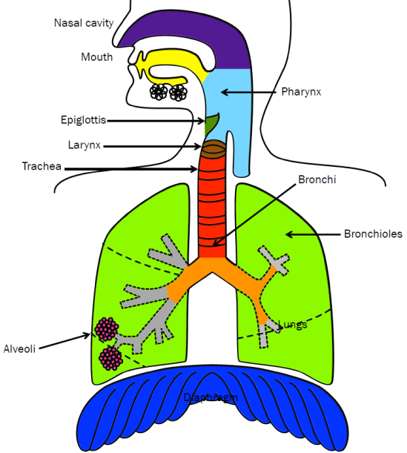

13. Describe the types of lung damage that can be caused by direct and indirect smoking.

Description | Mark
Smoking damages blood vessels and can make them thicken and grow narrower | 2
Your heart beats faster and blood pressure increases | 1
Clots can form blocking blood flow | 1
Asthma is a chronic lung disease that makes it harder to move in and out of your lungs | 1
Lung cancer | 1
 | /6

